|  |
| --- |
| **We need to do some settings to the POS System.** |
|  |

Such as:

1. Setting business configuration.
2. Setting POS workstation.
3. Setting Tax.
4. Setting Discount.
5. Payment Method
6. Notification
7. Extra Fee.
8. Customer Receipt.
9. Online Ordering
10. Sale Types.

|  |
| --- |
| **We discuss some need points for the POS System.** |

1. **Setting business configuration.**

We are able to see some information on the Business Configuration form.

Analyzing the setting business configuration and what, do we need to configure the POS system? How to handle it from admin.

Such As:

**Basic Type**

**Restaurant Quick Service**

**Retail**

**Beauty Salon**

**Basic Information**

**For Cashier Printing**

**E-Receipt**

**Please see the below screen.**

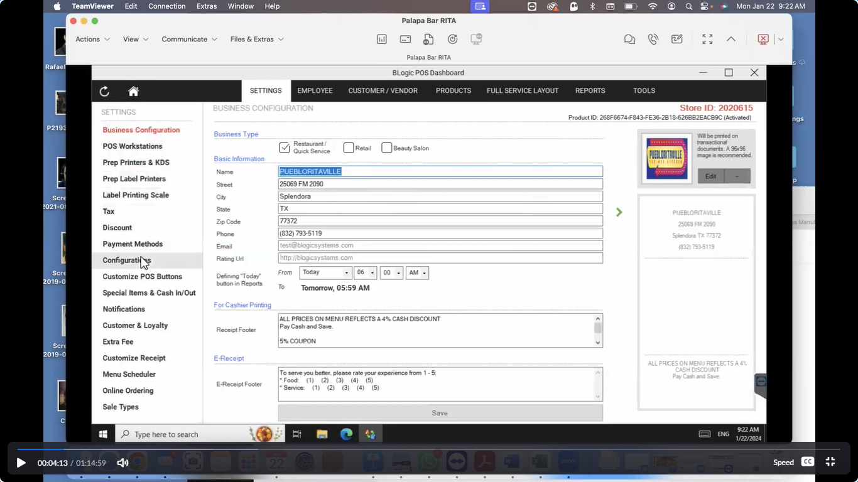

1. **Setting POS Workstation.**

We are able to see some information on the POS Workstation Form.

We analyzed as per some requirements how to connect the POS and PAX devises with our application and then how to show the listing to the POS and PAX devises on the workstation page.

Such As: Please see the below screen.

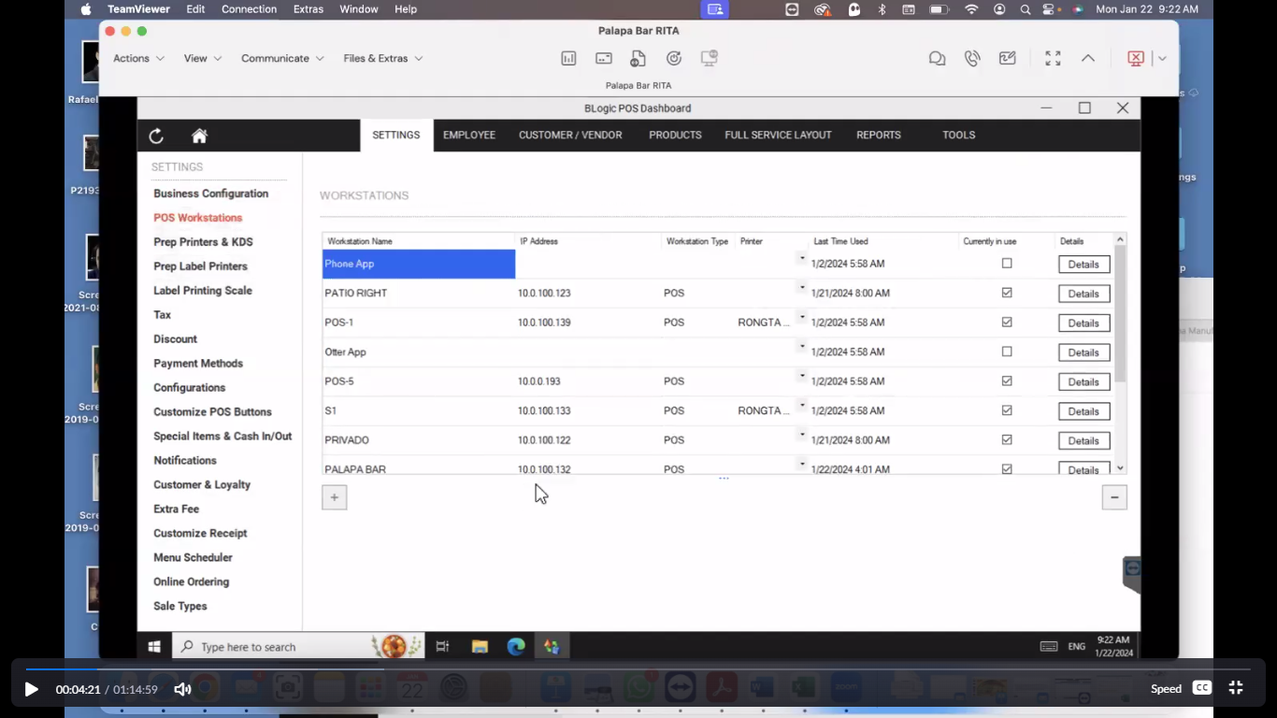

1. **Prep Printers & KDS**

We are able to see some information on the prep printers & KDS Form.

We analyzed as per some requirements how to connect the prep printers devises with our application and then how to show the listing to the prep printers devises on the prep printers & KDS page.

Such As: Please see the below screen.

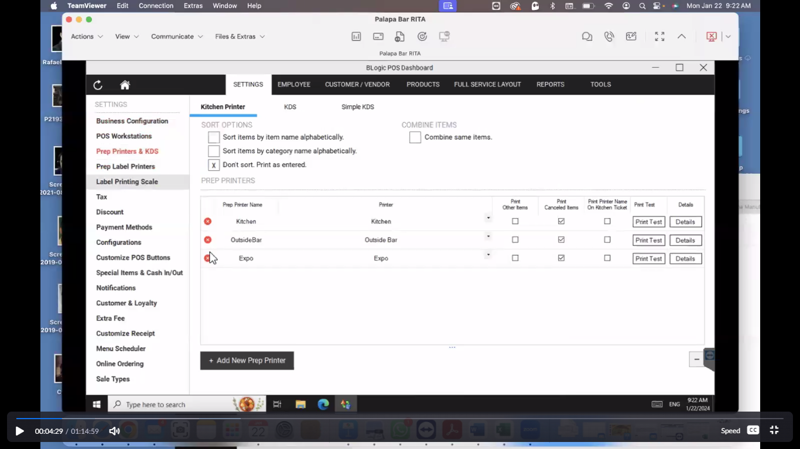

1. **Prep Label Printers:** client does not know about it.
2. **Label Printing Scale:** client saying I do not use it.
3. **Tax**

We are able to see some information on the tax Form.

The client says the taxes module is very clear to me.

The client says this is very easy for me to just put the taxes on it right here.

It says that I can change the tax value at the drop of a hat. By clicking on the tax. In addition, we can create a new tax.

Such as: Please see the below screen.

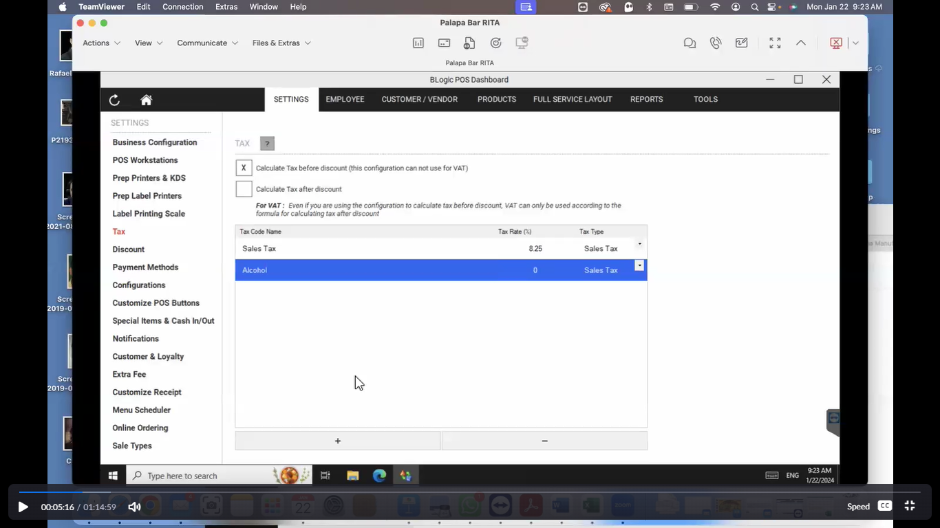

1. **Discount**

We are able to see some information on the discount Form.

The client saying you can apply some discount here.

Here are some different types of categories to discount.

Such as:

1. **Store Discount scheme**
2. **Categories Discount scheme**
3. **Pre-Defined Discount**
4. **Mix & Match:** The client saying I do not know something like this on discounts.

Please see the below screen**.**

1. **Store Discount scheme**

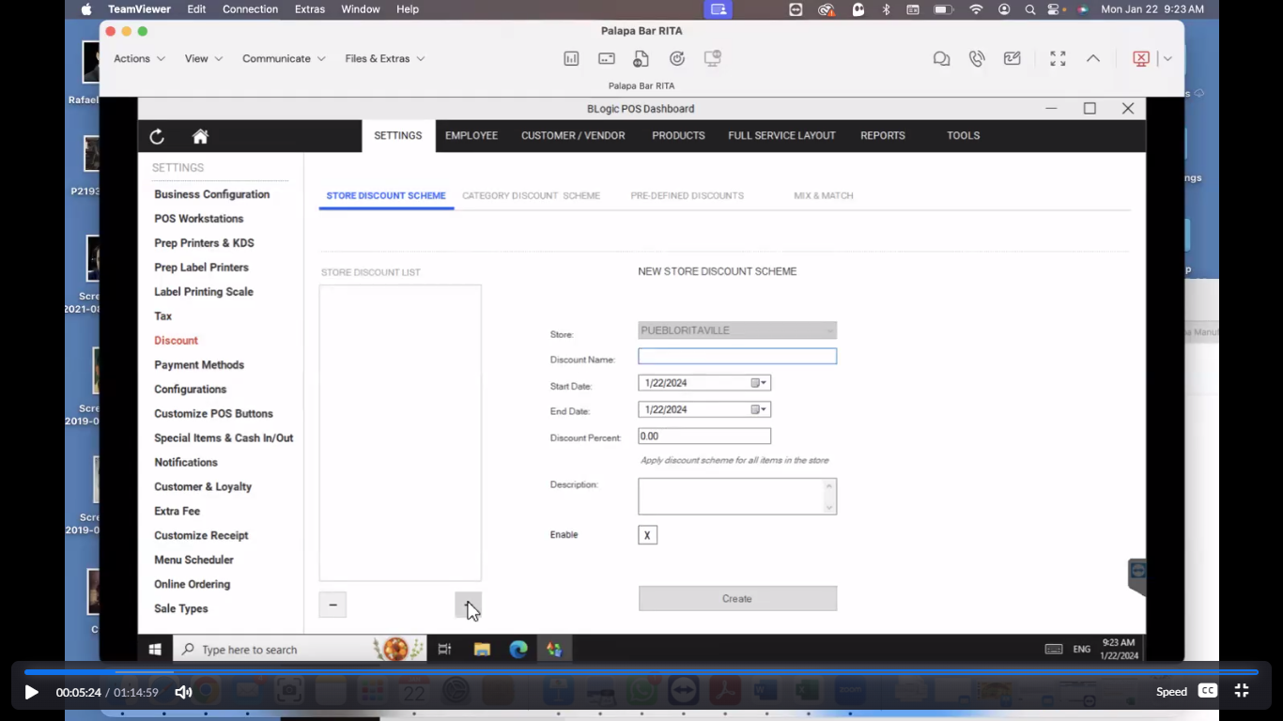

1. **Categories Discount scheme**

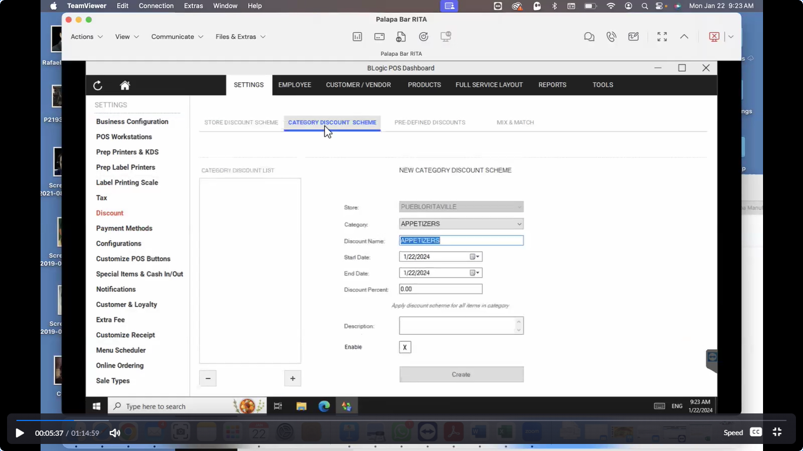

1. **Pre-Defined Discount**

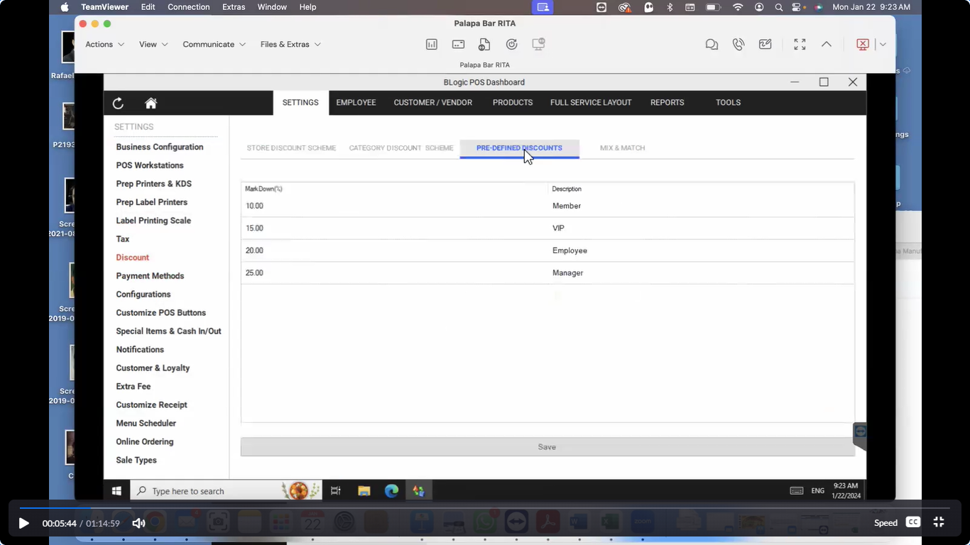

1. **Mix & Match**

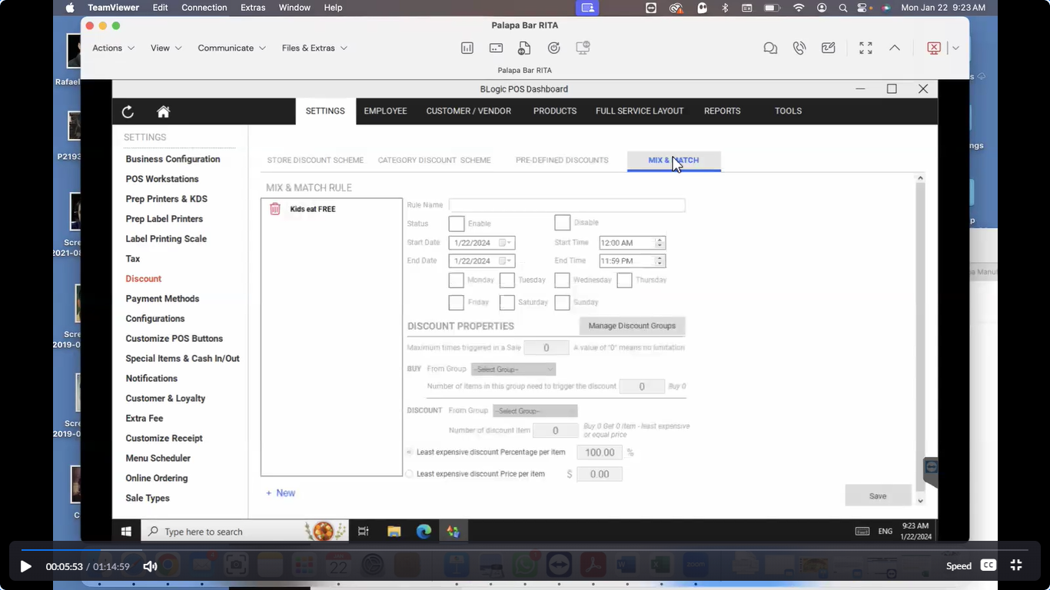

1. **Payment Method**

We are able to see some information on the payment method form.

Note: - The client said that in the last meeting, I had discussed with you about the open bar. You enable these so you can be able to charge. In addition, hold the information to your credit card. In addition, then once you have the credit card on file you can give, you give it back to the customer. (Say something like that)

Please see the below screen.

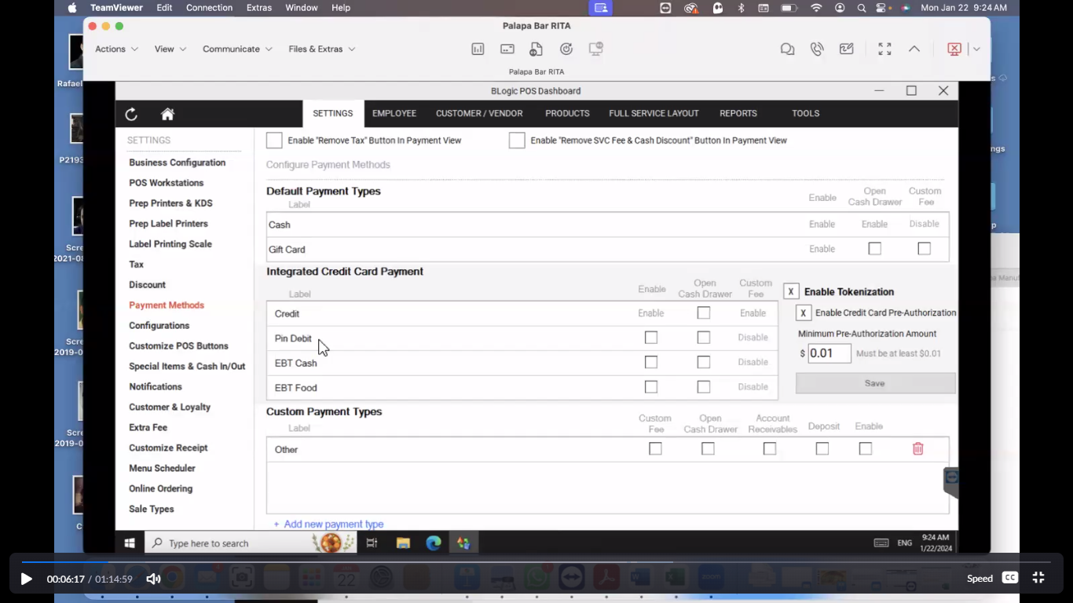

Note: - **Custom Payment Types.**

The client said you could create one or more custom payment types here.

Such as: - Uber

Please see the below screen.

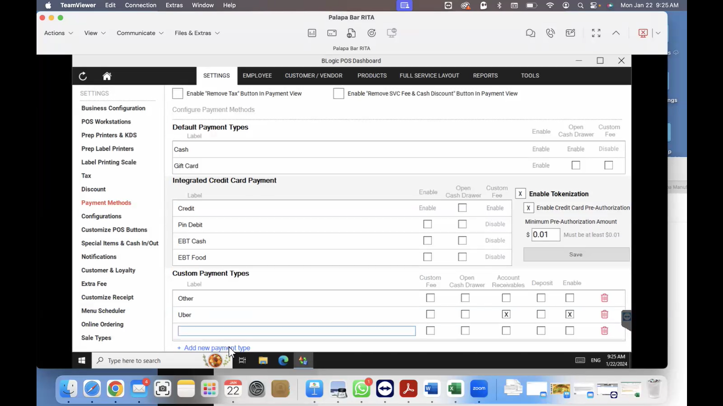

1. **Configurations**

We are able to see some information on the payment method form.

The client said there are a lot of configuration right here on top.

Please see the top of the screen below.

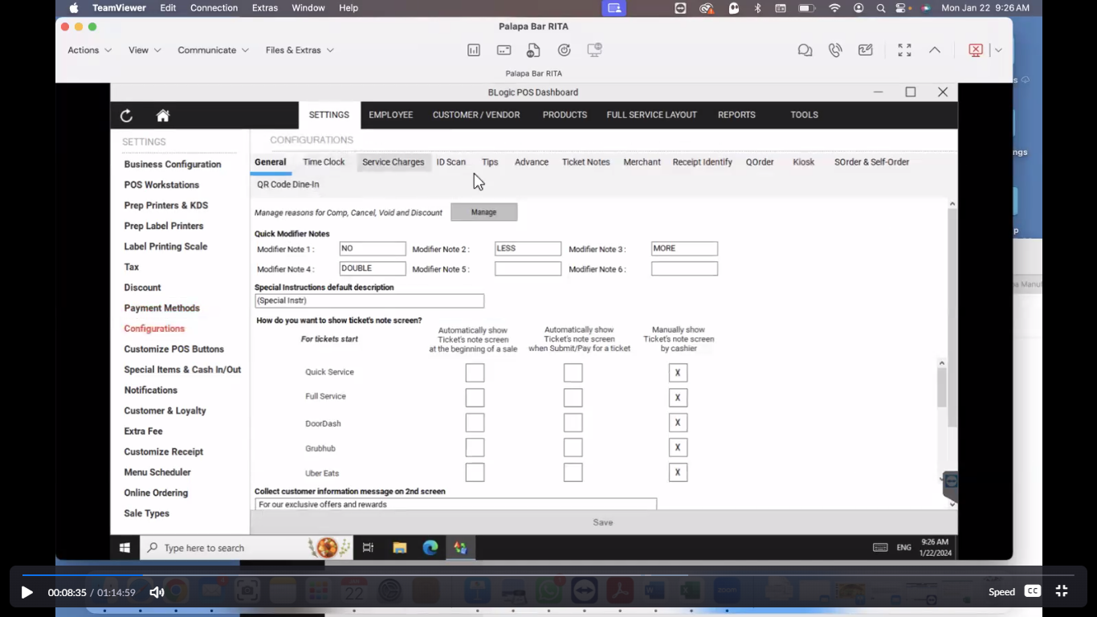

Here are some different types of configuration tabs on the configuration page.

Such as:

**Time clock, Service Charge, ID Scan, Tips, Advance, Ticket Notes, Merchant, Receipt Identity, QOrder, Kiosk, SOrder& Salf-order, QR Code Dine-In.**

**Time clock:** Please see the top of the screen below.

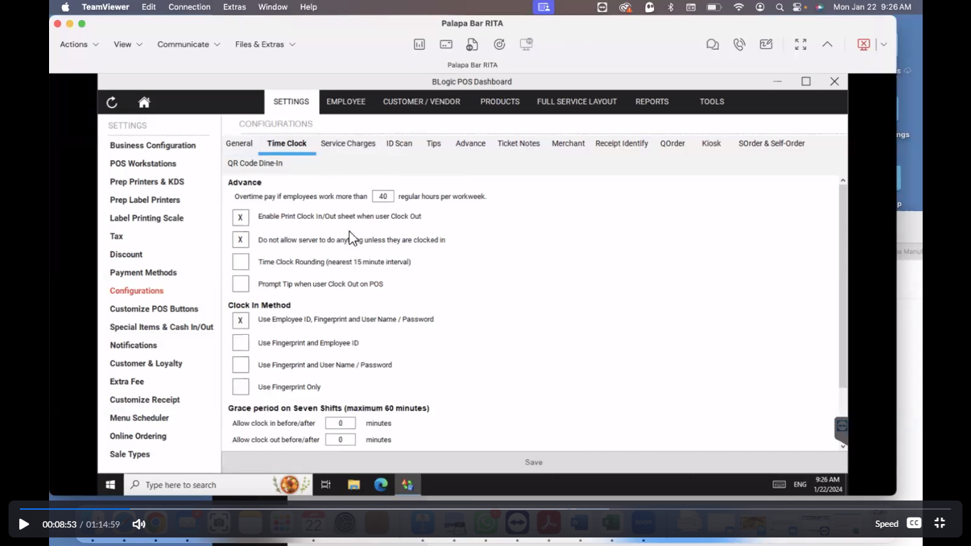

**The client said, we are not using this functionality.** (Say something like that)

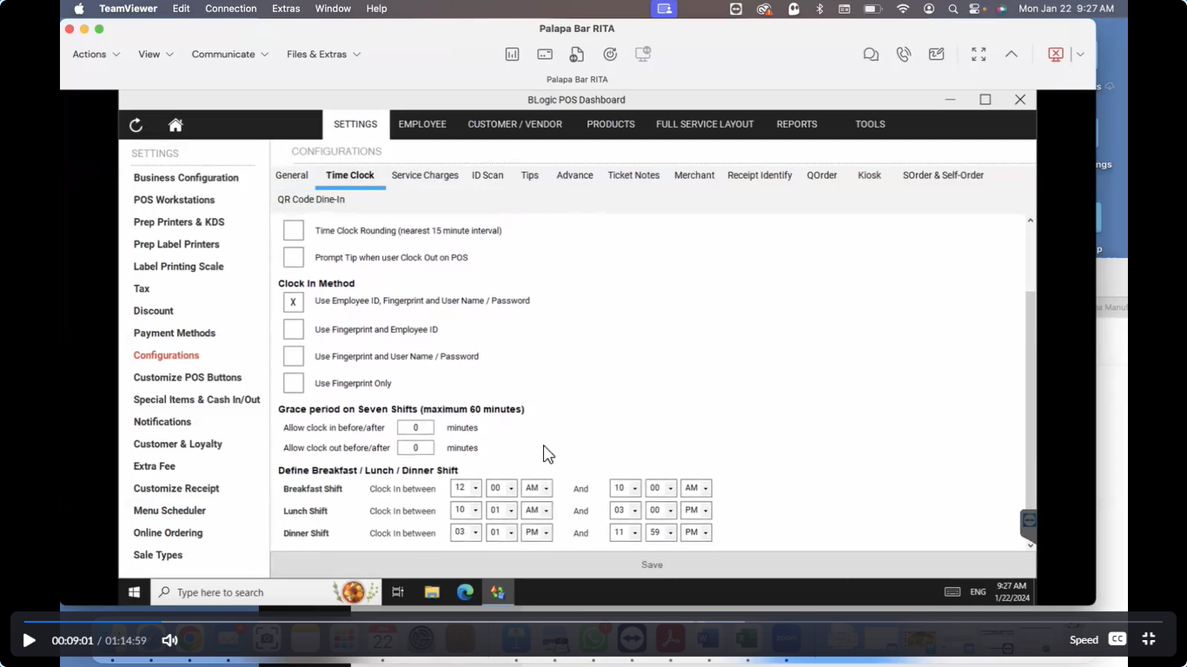

**Service Charge:** The client said you could set the server charge here.

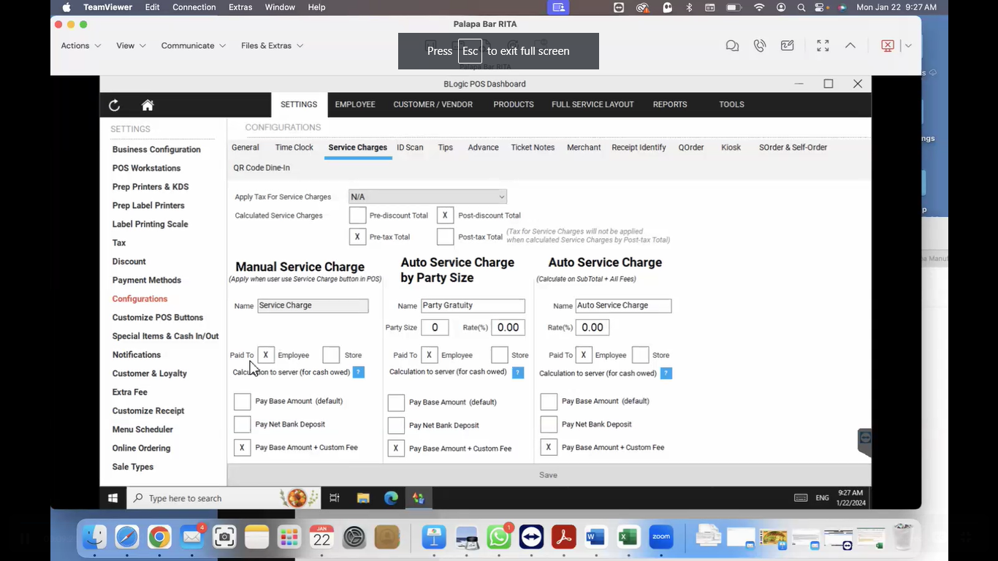

**ID Scan:** Did not say anything special about IDscan**.**

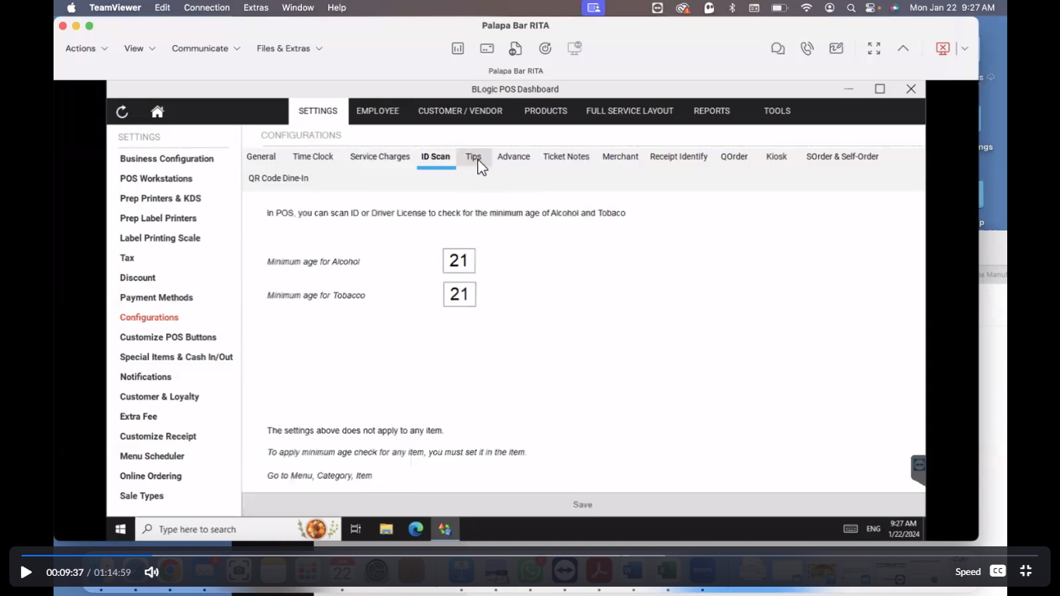

**Tips: (Important):** The client said we could set manual tips from here.

The client said you can customize it right here. 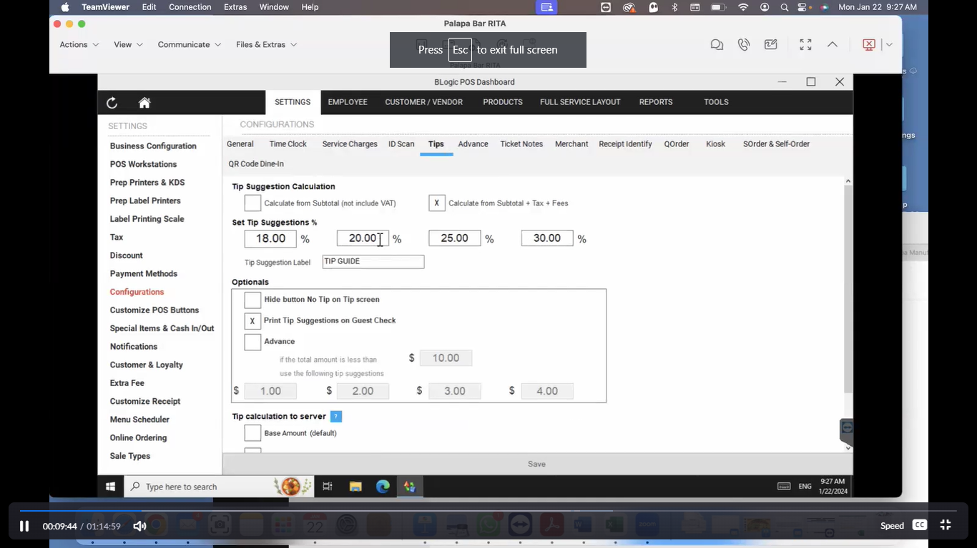

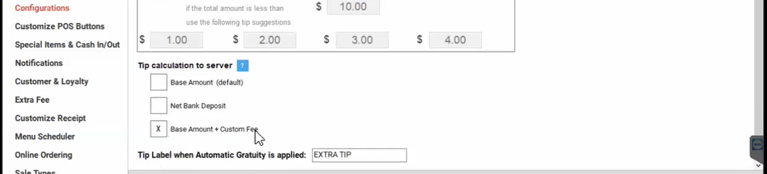

(Say something like that)

Cash discount that you we discuss in the previous meeting. Exactly. So. That is what I say. It is hard for me to tell you what cash discount is. How that works? Because there are so, many things that you need to know about it.

In this case they are talking about. If you're gonna get paid these tips on base amount or plus custom fee. So this custom fee is in so many other thing or so many other pages that I don't know.

**Advance:** The client said I don't know what that is. Why are using in the application.

The client said you know why are using Advance in the application. Then you could implement this module.

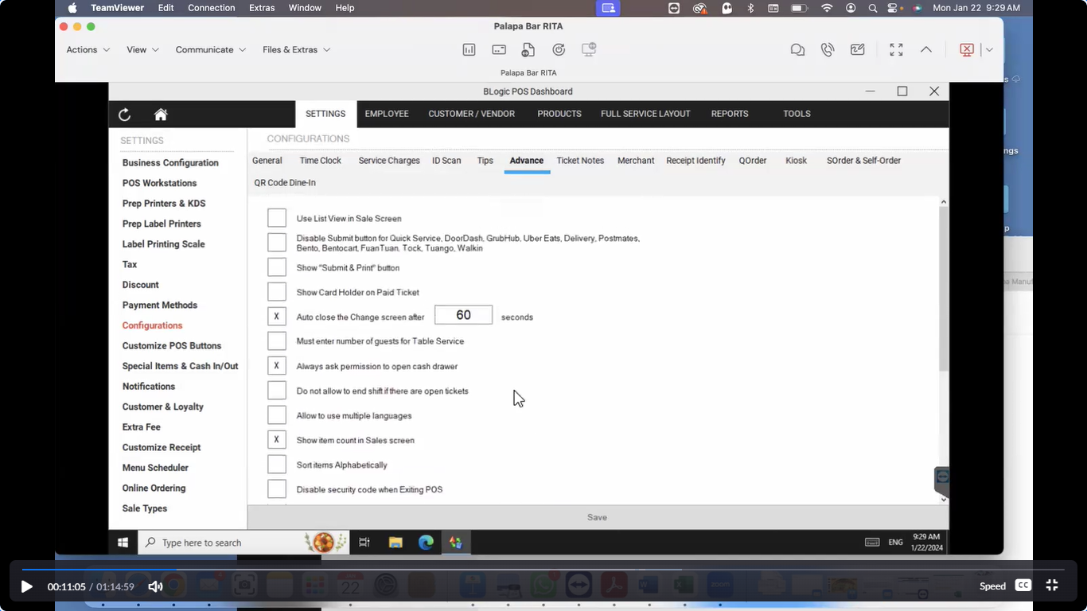

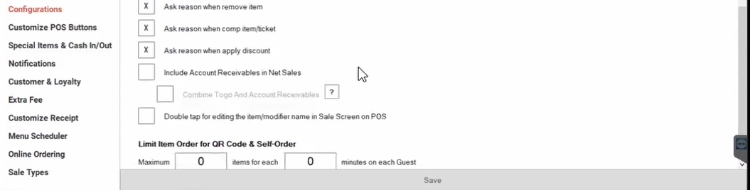

**Ticket Notes**: The client has not given any suggestions for.

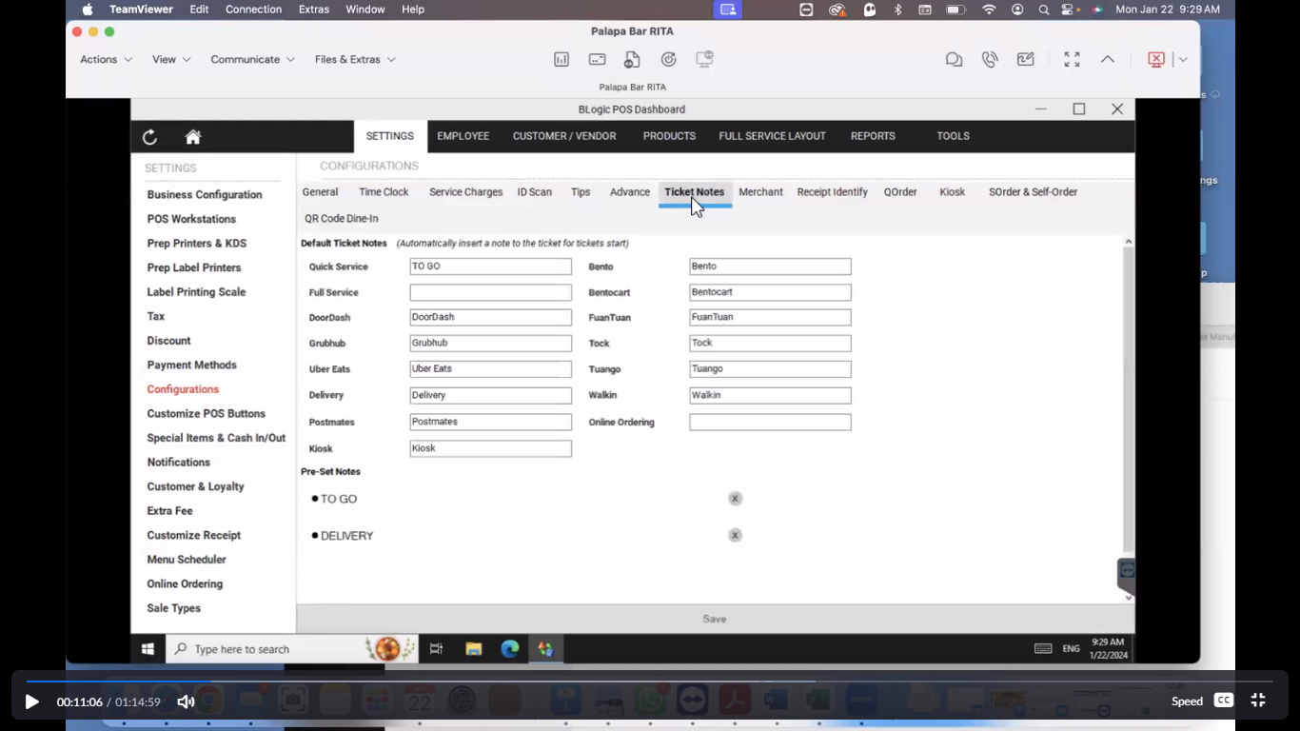

**Merchant (Completed):** The client says we can charge if the customer pay via credit card. This option we can apply in the merchant tab.

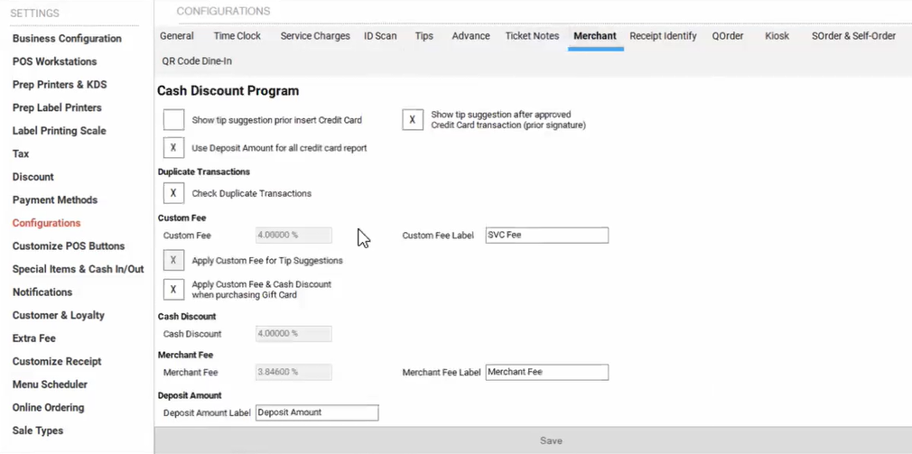

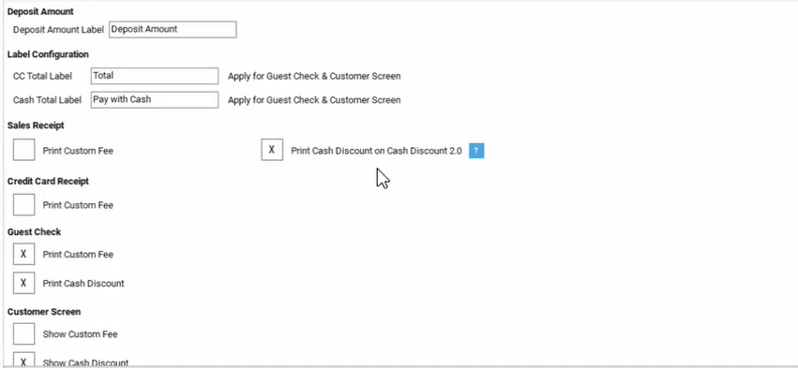

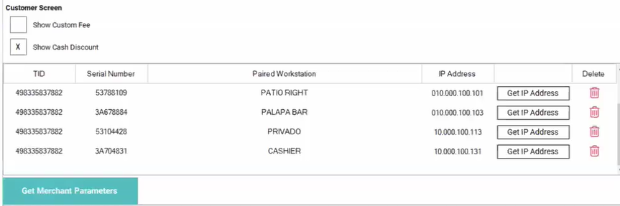

**Receipt Identity:** The client has not given any suggestions for.

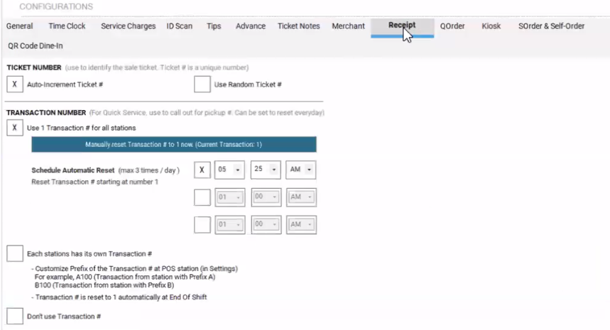

**QOrder:** The client has not given any suggestions for.

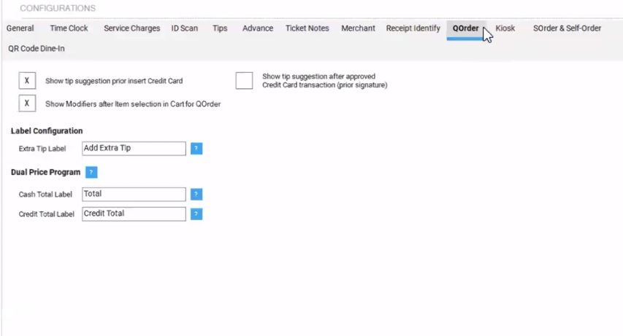

**Kiosk:** The client has not given any suggestions for

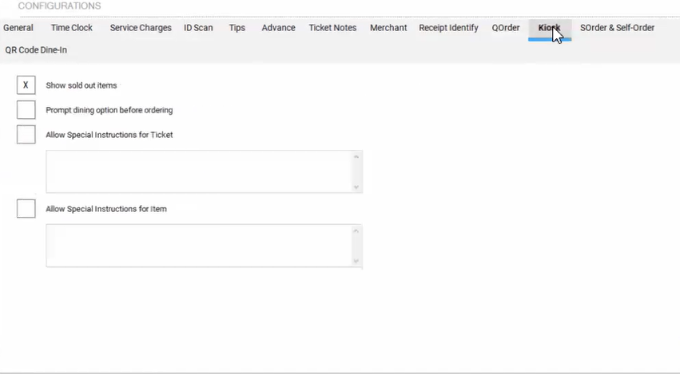

**SOrder& Salf-order:** The client has not given any suggestions for

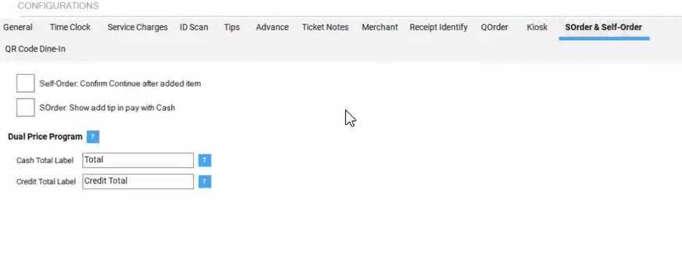

**QR Code Dine-In:** The client has not given any suggestions for

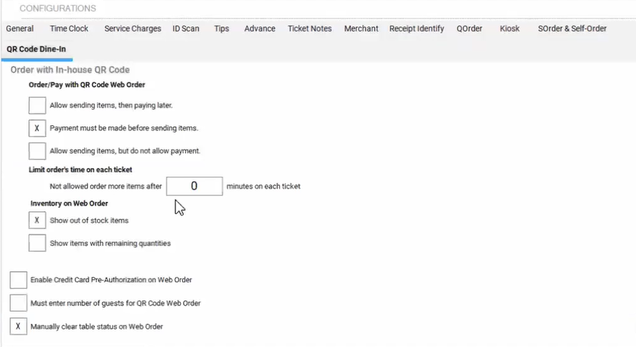

1. **Customize POS Button**

The client said we can change the button name and item color and size.

We are able to see some information on the customize POS button page.

(Say something like that)

The group, which is appetizer breakfast, enchiladas burritos. This is this one, this one right here group.

Modifier button or modifier button and item button. You can change it right here with the naming code and everything I mean color and everything.

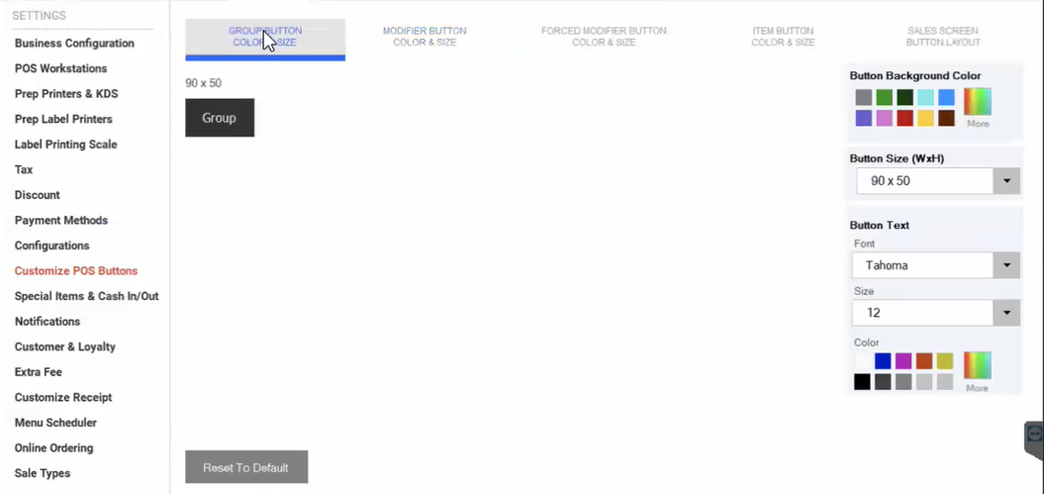

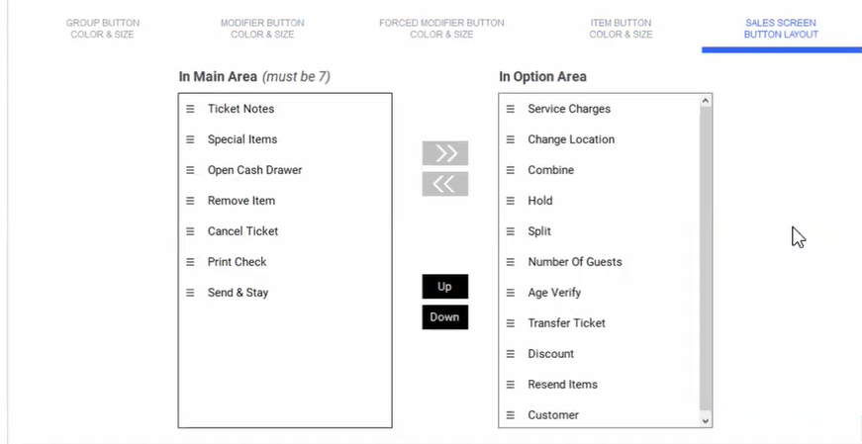

1. **Special item & Cash In/Out**

We are able to see some information on the special item & cash In/Out form.

Please see the top of the screen below.

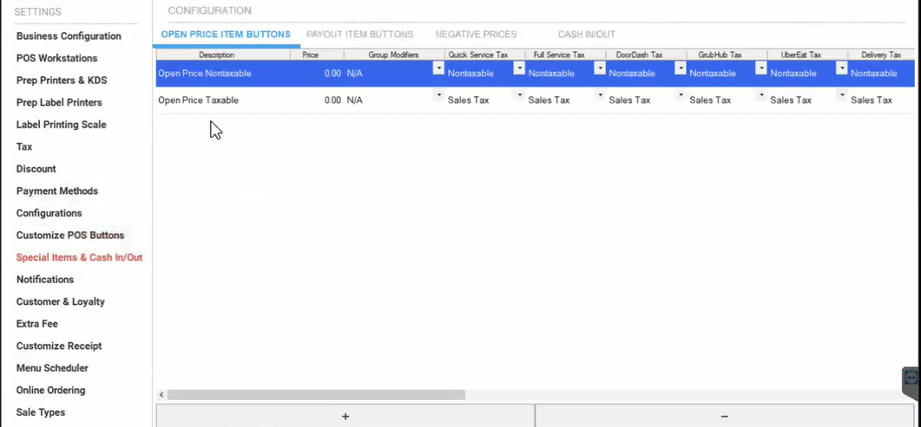

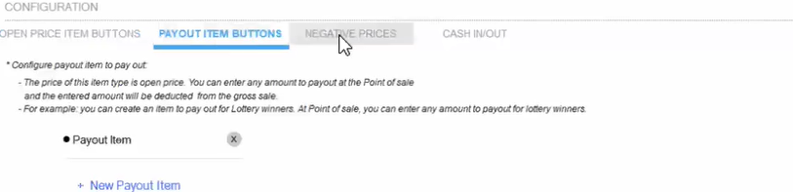

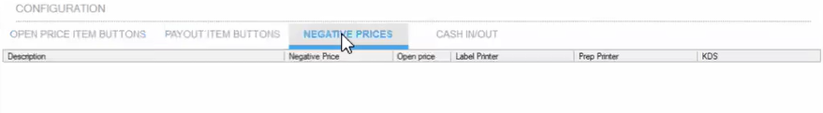

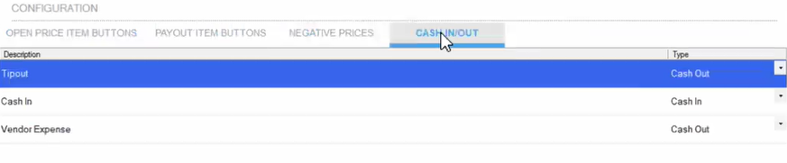

1. **Notification**

We are able to see some information on the notification form.

(Say something like that)

What about everything will happen here? But I'm sure we already we already have this team on on Tequila.

No, no, no, this is to who's gonna get notifications? Say if they do any shift, if they do any void, if they do any cancellation, if they do any com, if they do any discount, if they, if they lo low in this inventory

when they settled the batch, or when they settled the

every any notification for the owners or managers in case the right, in case they they people does something weird over here. They they cannot notification by email.

Please see the top of the screen below.

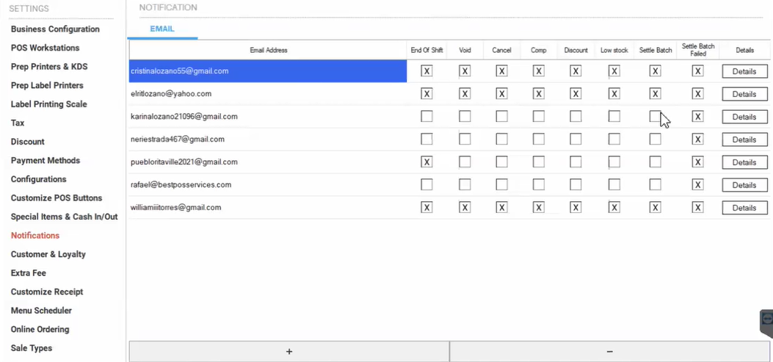

1. **Customer & Loyalty**

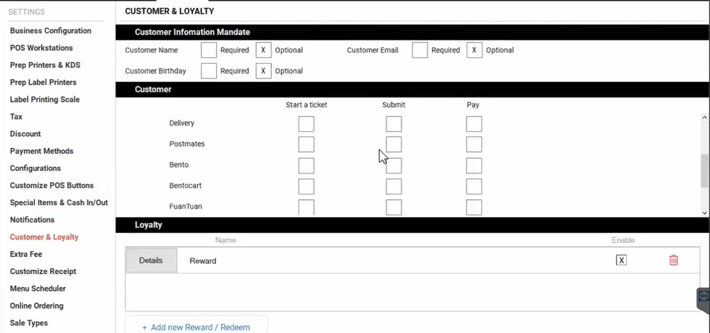

1. **Extra Fee**

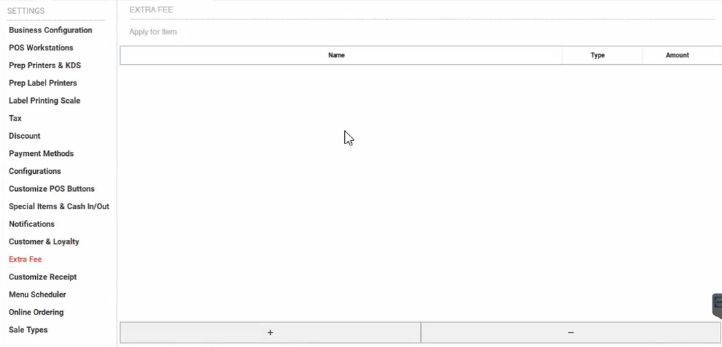

1. **Customize Receipt**

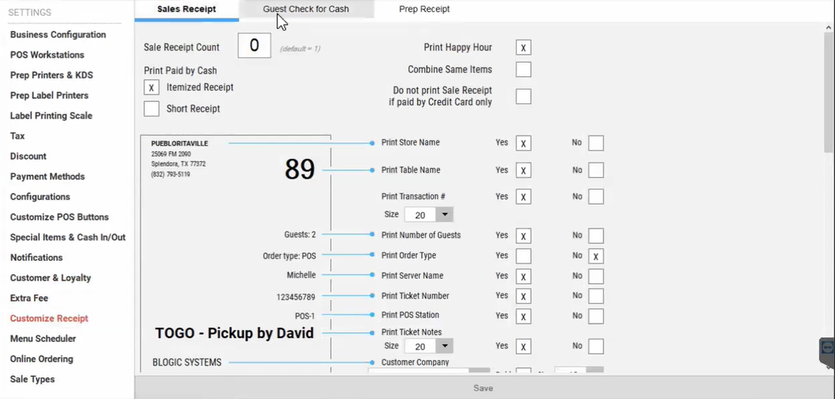

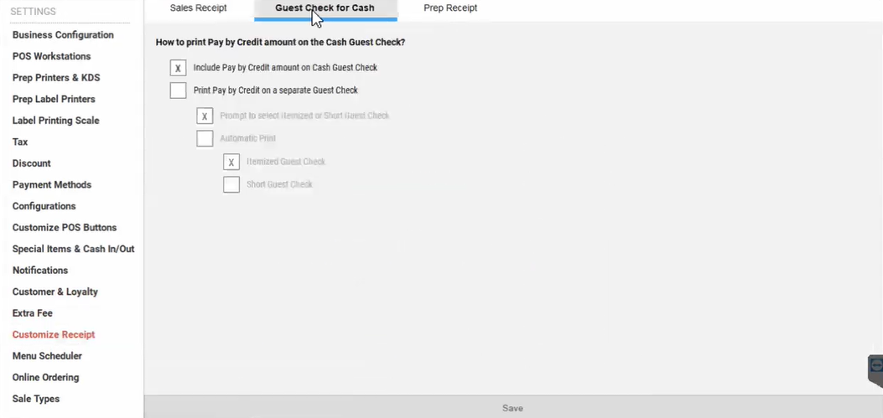

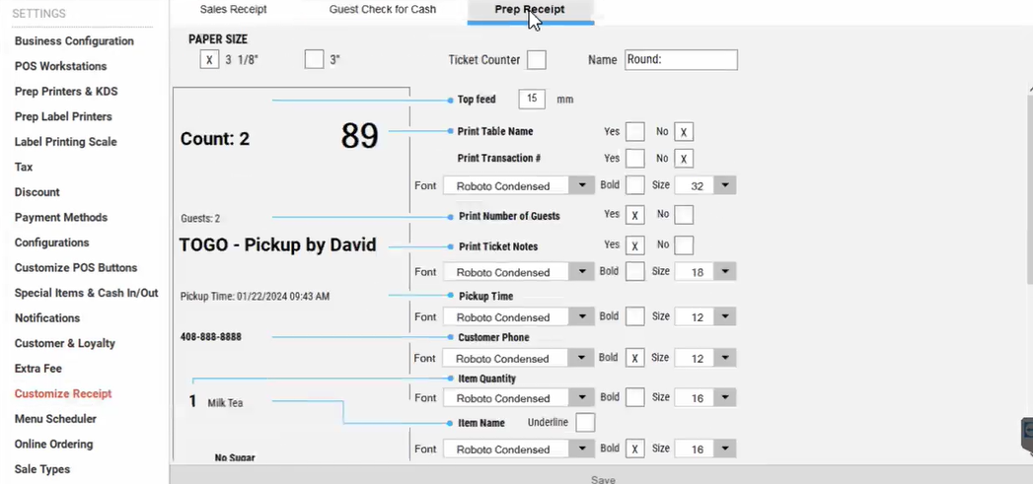

1. **Menu Scheduler**
2. **Online Ordering**
3. **Sale Types**